

**E-PROJECT REPORT**

**Clinic Management System**

**SUBMITTED BY**

**Saqib Hussain**

**Waseem**

**Owais**

**Aqib**

**By: Saqib Hussain**

**Table of Figures**

Table of Contents

Acknowledgment 4

Abstract 5

E-Project Synopsis 6

E-Project Analysis 7

E-Project Design 8

1. CHAPTER # 1 INTRODUCTION i

i

1.2 Problem statement ii

1.3 Project overview ii

1.4 Problem Description. ii

1.4.1 General statement ii

1.4.2 Development problems iii

1.5 Solution to the problems iii

1.6 Project scope iv

2 Chapter # 2 PROJECT OVERVIEW v

2.1 Home page v

2.2 About us vi

2.2.1 lab instrument vii

2.2.2 lab instrument Add to cart ix

2.3 Navigation x

2.3.1 Education xi

2.3. online class xii

2.4 next courses xii

2.4.1 medical bussiness xiv

2.4. pharmacy xv

2.5 pharamacy add to cart xvi

2.6 Contact us xvii

2.7 login system xviii

2.8 signup system xix

2.9 xx

3 Chapter # 3 Admin panel xxi

3.1 Doctor Records xxi

3.2 Lab instrument xxii

3.3 Pharmacy Records xxiii

3.4 Bussiness Records

3.5 Education class Record

# 

# Acknowledgment

I want to thank my instructors and advisors for their guidance and support throughout the process. Their expertise and experience have been invaluable, and I am grateful for the opportunity to learn from them.

# Abstract

Welcome to our clinic management system! Here, you will find a comprehensive platform designed to streamline operations for healthcare providers and enhance the patient experience. From appointment scheduling to medical record management, we offer a range of features tailored to meet the needs of both clinics and their patients.

Our system supports various healthcare practices, including general medicine, pediatrics, and specialty clinics. No matter your practice type, our tools are designed to improve efficiency and organization.

We understand that managing a clinic can be complex, which is why we provide intuitive user interfaces and detailed tutorials for each feature. This allows staff to navigate the system with ease, ensuring that patient care remains the top priority.

# E-Project Synopsis

This clinic management system project is a comprehensive platform designed to enhance the efficiency and effectiveness of healthcare practices. It aims to provide users with a wide range of tools for managing patient care and clinic operations seamlessly.

The system features a user-friendly interface that allows healthcare professionals to easily navigate and utilize its functionalities, including appointment scheduling, patient registration, and billing management. Users can access detailed patient information and treatment histories to improve care delivery.

One of the key features of the system is its extensive capabilities for managing various aspects of clinic operations. This includes tools for telehealth services, automated appointment reminders, and secure communication between patients and providers. The platform is designed to support both well-established clinics and smaller practices looking to streamline their processes.

4o mini

All of the products on the website are carefully selected and vetted to ensure that they meet our high standards for quality and value.

In addition to our product offerings, we also strive to provide our users with a seamless and enjoyable shopping experience. The website features a number of user-friendly features, such as, personalized product recommendations.

Finally, we are committed to providing excellent customer service to all of our users. We have a dedicated customer service team available to answer any questions or concerns that users may have, and we offer a number of flexible and convenient shipping and return options to ensure that our users are satisfied with their purchases.

Overall, our Clinic website project is designed to be a one-stop destination for all of your fragrance needs. We hope that you will visit our us soon and experience the convenience and value that we have to offer.

# E-Project Analysis

# A clinic management system project is a complex undertaking that requires a wide range of skills and expertise. The following is a high-level analysis of the key considerations and challenges that may arise during the development of a clinic management system:

# Design and Layout

# The visual design of the clinic management system is critical, as it will be the primary interface for healthcare professionals and patients. It is essential to create a visually appealing and intuitive layout that facilitates easy navigation and enhances user experience.

# Patient Information and Presentation

# A clinic management system must provide detailed and accurate information about patients, including medical histories, treatment plans, and appointment schedules. Presenting this information in a clear and concise manner is crucial for effective patient care and decision-making.

# Functionality

# The system needs robust functionalities, such as appointment scheduling, patient registration, billing management, and telehealth services. Integration with electronic health records (EHR) is also important to ensure seamless access to patient data.

# Mobile Compatibility

# With the increasing use of mobile devices, it is essential that the system is optimized for mobile viewing. This includes a responsive design and fast loading times, allowing healthcare providers and patients to access the system from various devices.

# Data Security and Compliance

# Ensuring the security of sensitive patient information is paramount. The system must comply with regulations such as HIPAA to protect patient privacy and data integrity. This includes implementing secure authentication methods and data encryption.

# User Training and Support

# A clinic management system should include comprehensive training resources and support for users. This ensures that healthcare professionals can effectively utilize the system's features and troubleshoot any issues that arise.

# Marketing and Branding

# If the system is offered as a service to clinics, a strong marketing strategy is essential for attracting new clients. This could include targeted outreach, demonstrations, and testimonials from existing users.

# Overall, the development of a clinic management system requires a combination of design, technical, and healthcare expertise. Careful planning and execution of each aspect of the project are vital to ensure the success and usability of the system.

# E-Project Design

# The goal of this clinic management system project is to create an efficient online platform for healthcare providers to manage patient care and clinic operations. Our target audience includes medical professionals and administrative staff looking for a comprehensive solution to streamline their practice.

# The system will feature an easy-to-use interface that allows users to navigate through various functionalities, such as appointment scheduling, patient registration, and billing management. Each section will provide detailed information, including patient records, treatment histories, and scheduling options, ensuring that users can access the information they need quickly and efficiently.

# In addition to core management features, we also aim to provide educational resources about best practices in healthcare management. This can include articles on patient engagement, compliance regulations, and tips for optimizing clinic operations.

# To make the user experience as seamless as possible, the system will offer various integrations, such as electronic health records (EHR) and telehealth services, as well as secure payment processing. We will also have a dedicated support team available to assist with any questions or concerns.

# Overall, our goal is to create a clinic management system that not only facilitates efficient practice management but also serves as a valuable resource for healthcare professionals looking to enhance their operations and improve patient care.

# CHAPTER # 1 INTRODUCTION

# 

# Welcome to Clinic Management, your one-stop destination for all your healthcare management needs. Our e-project offers a comprehensive platform designed to provide a convenient and efficient experience for healthcare professionals and administrative staff.

# Our system features a wide range of tools to streamline clinic operations, including appointment scheduling, patient registration, billing management, and telehealth services. Whether you’re looking to enhance patient care, optimize administrative processes, or improve communication within your practice, you’ll find the solutions you need at Clinic Management.

# With our user-friendly interface, robust functionalities, and dedicated support team, we ensure that your experience is seamless and productive. We are committed to providing the best possible service, and we look forward to helping you enhance your clinic’s operations and patient care.

# 

## About us inside *Home* Page

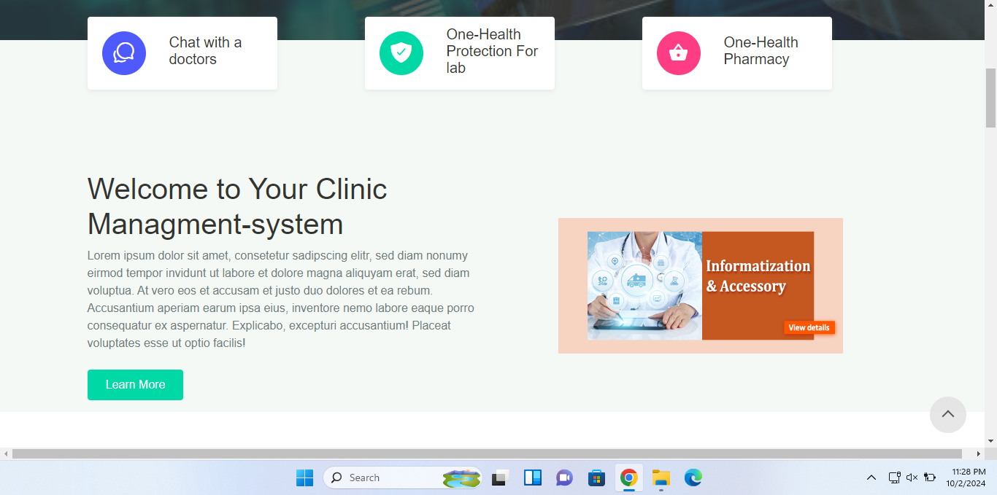

# 

## 

## Problem statement

Despite the abundance of options available in the Clinic industry, many customers still face challenges when trying to find the perfect scent. These challenges include:

Limited Accessibility: Many customers do not have easy access to a wide range of clinic, which makes it difficult for them to find the perfect scent that suits their needs.

Limited Information: Customers often have limited information about the clinic they are interested in, which makes it difficult for them to make an informed decision when purchasing a Clinic .

Inconvenient Shopping Experience: Shopping for clinic can be a time-consuming and overwhelming experience, as customers have to physically visit multiple stores to find the perfect scent.

# Welcome to Clinic Management, your one-stop destination for all your healthcare management needs. Our e-project offers a comprehensive platform designed to provide a convenient and efficient experience for healthcare professionals and administrative staff.

## Project overview

# Welcome to Clinic Management, your one-stop destination for all your healthcare management needs. Our e-project offers a comprehensive platform designed to provide a convenient and efficient experience for healthcare professionals and administrative staff.

## Problem Description.

### General statement

# Welcome to Clinic Management, your one-stop destination for all your healthcare management needs. Our e-project offers a comprehensive platform designed to provide a convenient and efficient experience for healthcare professionals and administrative staff.

about each Clinic and a user-friendly website. Additionally, Clinic offers fast shipping and excellent customer service to ensure a seamless and enjoyable shopping experience for customers. The platform is aimed to help customers to find their desired clinic with easy navigation and filtered search options. And also offers gift wrapping and gift card options for customers who wants to buy clinic as gifts.

### Development problems

The development of Clinic has presented several challenges that had to be addressed in order to ensure a successful launch of the platform. These challenges include:

Securing a wide range of high-quality clinic from top brands and independent Clinic rs to offer customers a diverse selection.

Creating a user-friendly website that is easy to navigate and provides detailed information about each Clinic .

Ensuring fast and reliable shipping to provide customers with a seamless shopping experience.

Developing an efficient and effective customer service team to provide prompt and helpful responses to customer inquiries.

Implementing a secure and reliable payment system to ensure the safety of customer transactions.

Developing a search and filter option for customers to easily find their desired clinic

Implementing gift wrapping and gift card options for customers who wants to buy clinic as gifts.

Despite these challenges, the development team has worked diligently to overcome them and create a platform that meets the needs of our customers

## Solution to the problems

The solution to the problem of limited accessibility and limited information in the Clinic industry is to provide a convenient and easy shopping experience for customers through an e-commerce platform. Clinic aims to solve this problem by offering a wide range of clinic from top brands and independent Clinic rs, as well as detailed information about each Clinic . Additionally, the platform will feature a user-friendly design, fast shipping, and an excellent customer service team to ensure a seamless and enjoyable shopping experience for customers. Additionally, the website will feature a Gift wrapping and gift card options for customers looking to buy clinic as gifts. With these features, Clinic aims to make it easy for customers to find their perfect scent and have a pleasant shopping experience

## Project scope

The scope of the Clinic project includes the following:

* Development of an e-commerce platform for the sale of high-quality clinic from top brands and independent Clinic rs
* A user-friendly website that makes it easy for customers to navigate and find the clinic they are interested in
* Detailed information about each Clinic including notes, longevity, and sillage
* Fast shipping and excellent customer service to ensure a seamless and enjoyable shopping experience for customers
* Gift wrapping and gift card options for customers looking to buy clinic as gifts.
* Filtered search options to help customers to find their desired clinic easily
* A mobile-responsive design to ensure that customers can access the platform on any device

The project scope does not include the physical production or distribution of the clinic.

# Chapter # 2 PROJECT OVERVIEW

# Welcome to Clinic Management, your one-stop destination for all your healthcare management needs. Our e-project offers a comprehensive platform designed to provide a convenient and efficient experience for healthcare professionals and administrative staff.

# Welcome to Clinic Management, your one-stop destination for all your healthcare management needs. Our e-project offers a comprehensive platform designed to provide a convenient and efficient experience for healthcare professionals and administrative staff.

# Welcome to Clinic Management, your one-stop destination for all your healthcare management needs. Our e-project offers a comprehensive platform designed to provide a convenient and efficient experience for healthcare professionals and administrative staff.

## Layout

The Clinic Management system is designed with a user-friendly and easy-to-navigate layout. The homepage features a prominent search bar, allowing healthcare professionals to quickly search for specific patient records or appointment schedules. The system also includes a clear and intuitive navigation menu, with categories such as "Upcoming Appointments," "Patient Records," and "Billing Management."

The patient record pages provide detailed information about each patient, including medical history, treatment plans, and notes from previous visits. The system is regularly updated with new features and functionalities to enhance clinic operations and improve patient care. With a focus on usability, Clinic Management ensures that healthcare providers can efficiently manage their practices while delivering high-quality care to their patients.

4o mini

## Responsive Layout

The Clinic Management system is designed with a user-friendly and easy-to-navigate layout. The homepage features a prominent search bar, allowing healthcare professionals to quickly search for specific patient records or appointment schedules. The system also includes a clear and intuitive navigation menu, with categories such as "Upcoming Appointments," "Patient Records," and "Billing Management."

The patient record pages provide detailed information about each patient, including medical history, treatment plans, and notes from previous visits. The system is regularly updated with new features and functionalities to enhance clinic operations and improve patient care. With a focus on usability, Clinic Management ensures that healthcare providers can efficiently manage their practices while delivering high-quality care to their patients.

### *Home page add to cart*

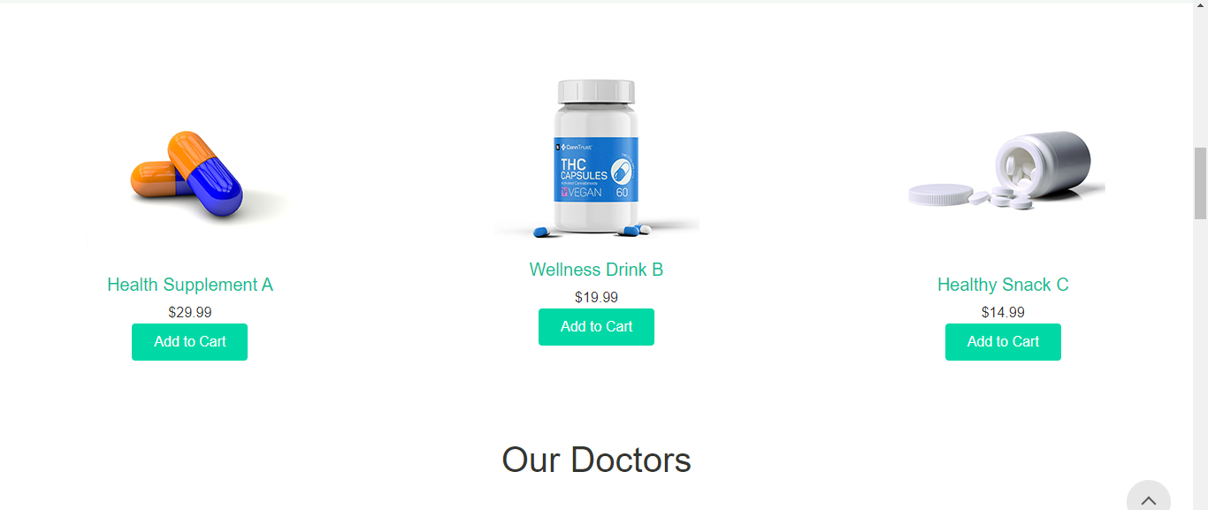

About :



Doctors

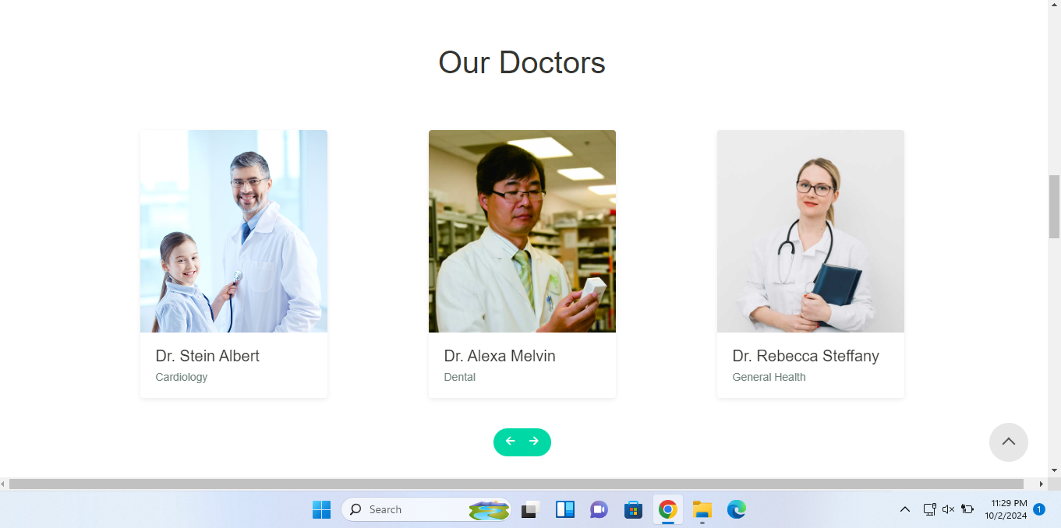

Get Appointment:

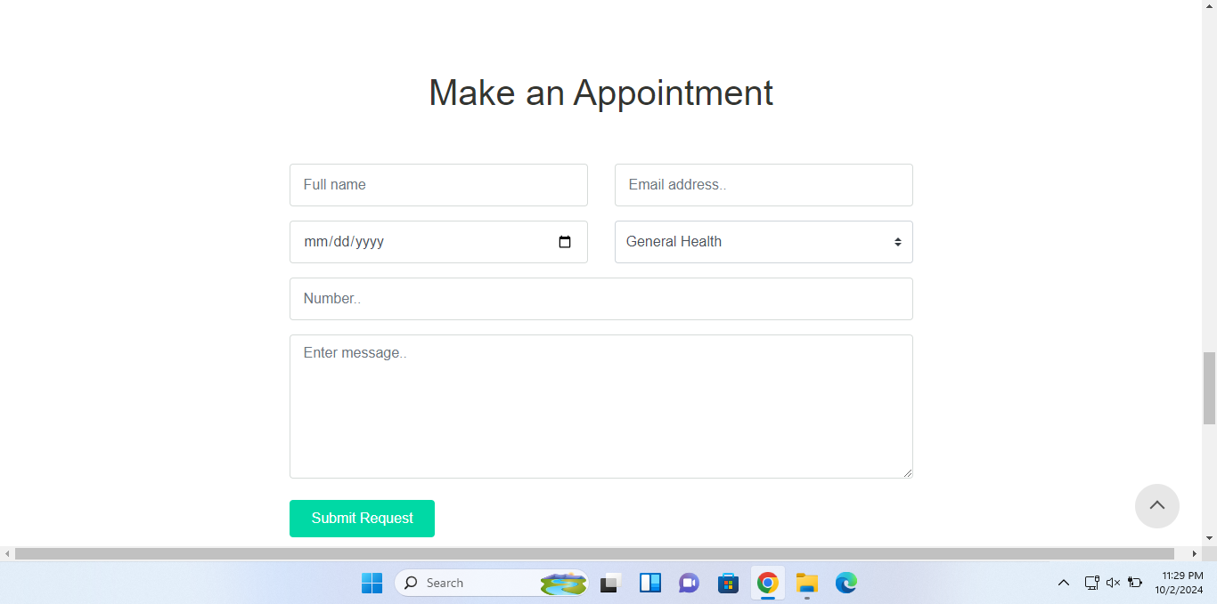

**Footer:** Include All pages

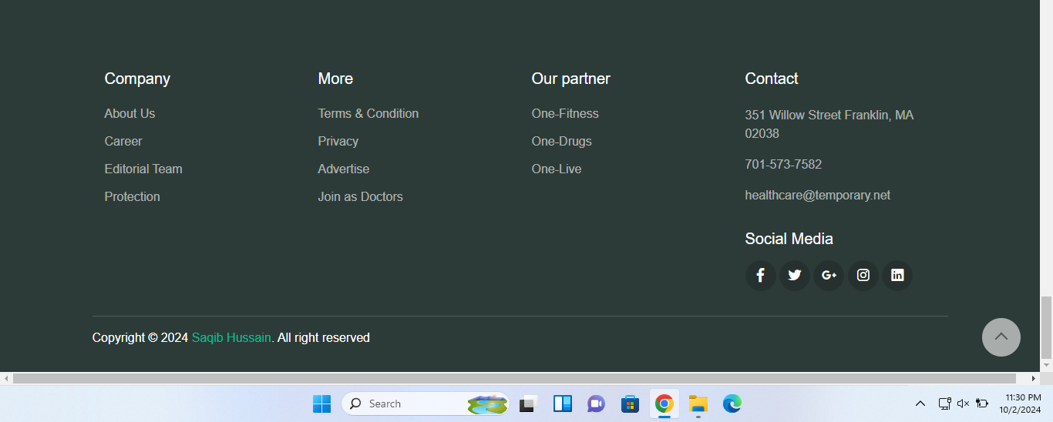

Home page Latest News:

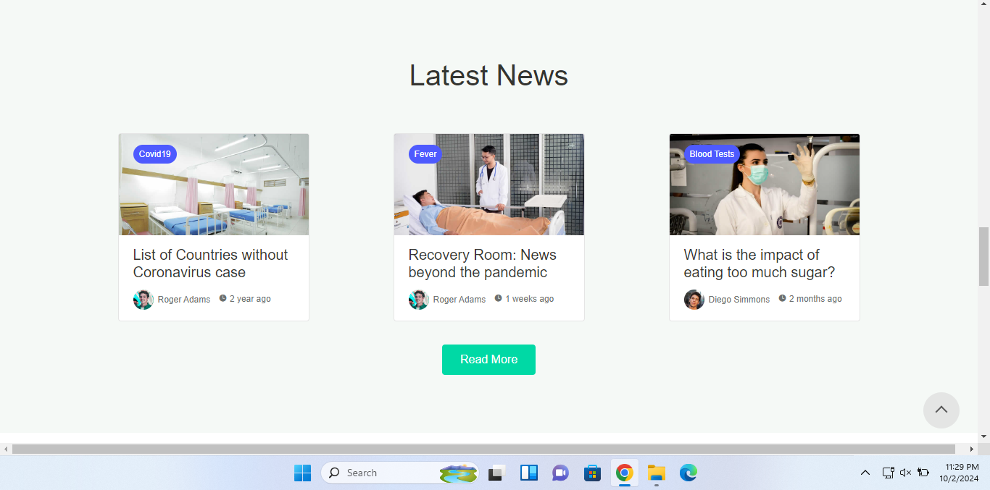

About us pages:

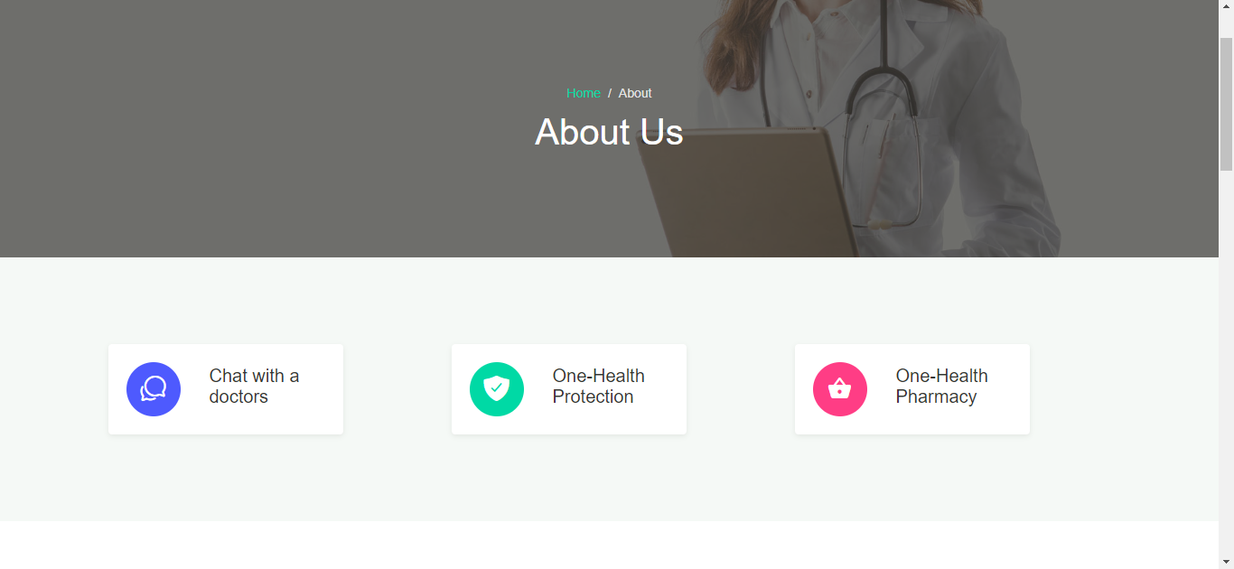

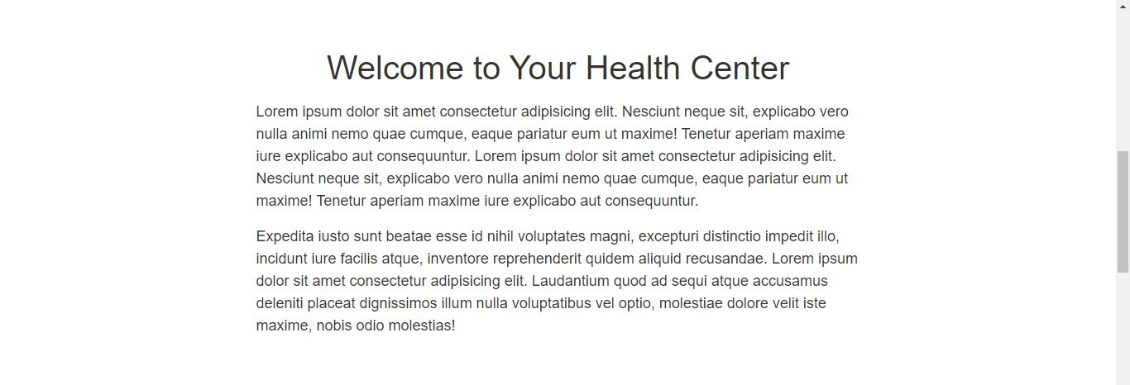

Doctor pages:



View your Doctor and contact:



News Pages in Website:

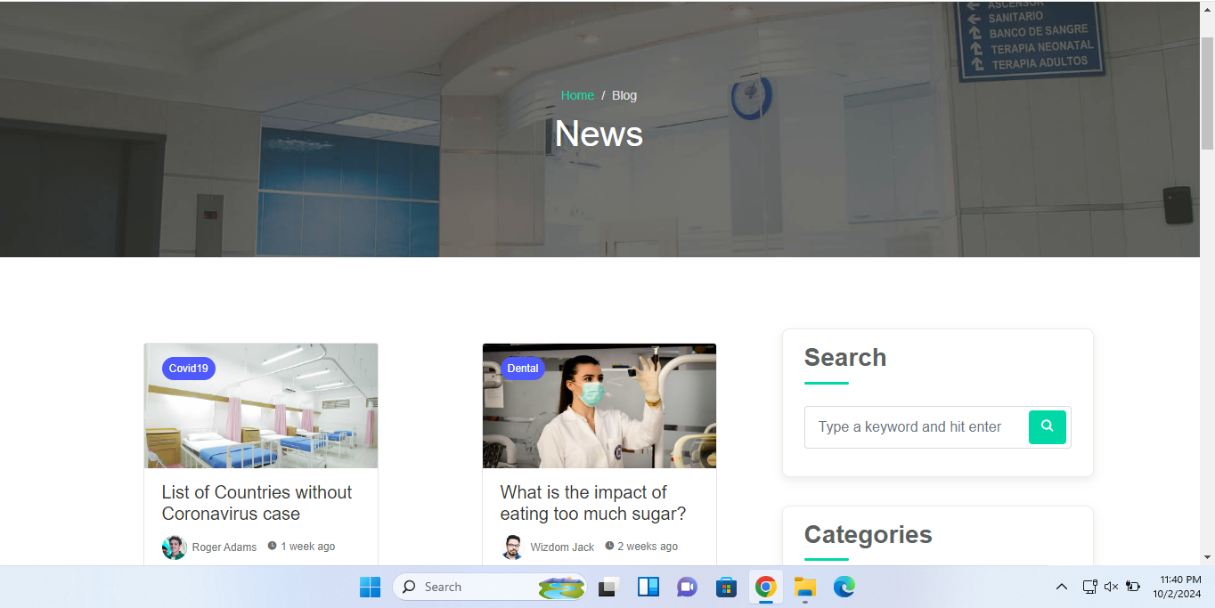

### 

### 

### Lab Instrument pages: Add slider

### 

### 

## Navigation

The Clinic Management website is designed with intuitive navigation to make it easy for customers to find the clinic they are interested in. The website features a clear and easy-to-use navigation menu, which also includes a mega menu that allows customers to easily browse clinic by brand, category, fragrance family, etc. This feature allows customers to quickly find the clinic they are interested in without having to navigate through multiple pages.

The mega menu is prominently displayed on the homepage and is accessible from every page of the website. This allows customers to easily access the categories and subcategories of clinic and make their selection with ease.

Navigation in Asp.net Mvc:



Asp.net code

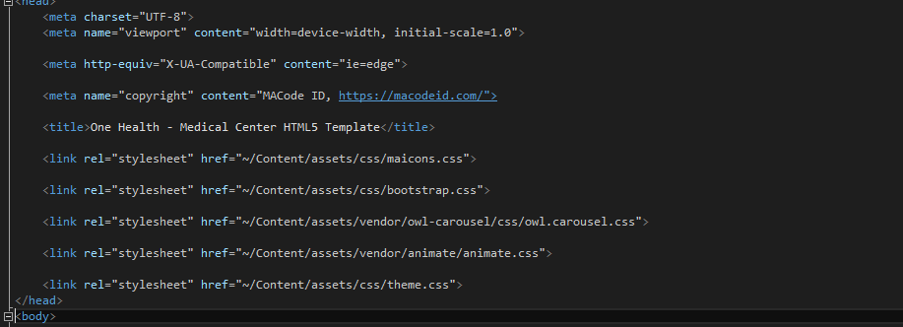

Overall, the navigation design of Clinic website is aimed to make it easy for customers to find the clinic they want to purchase and make the shopping experience more enjoyable

Lab instrument Add to Cart:

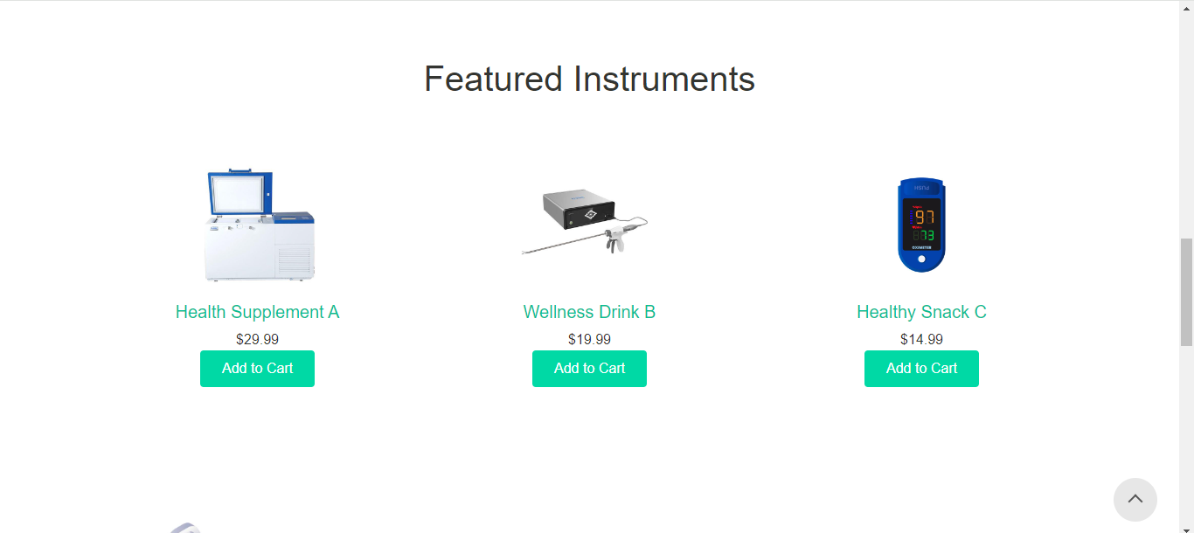

Code pic lab featured instrument

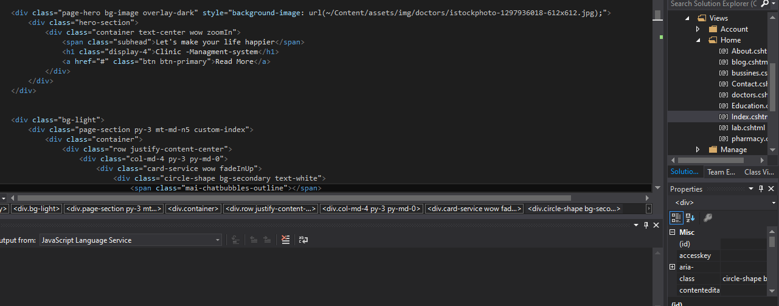

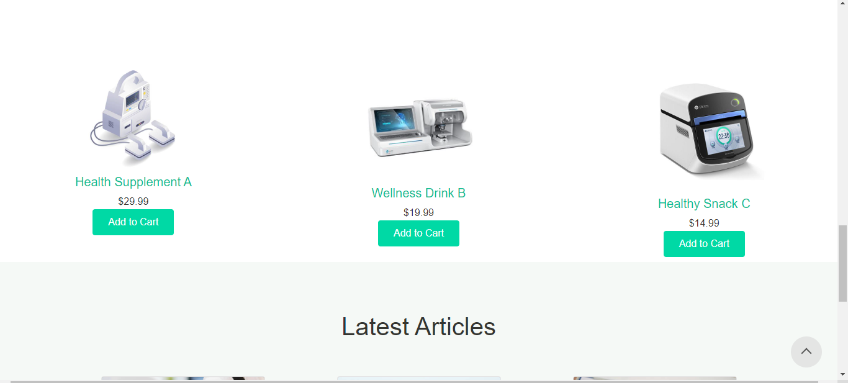

Latest News About lab instrument:

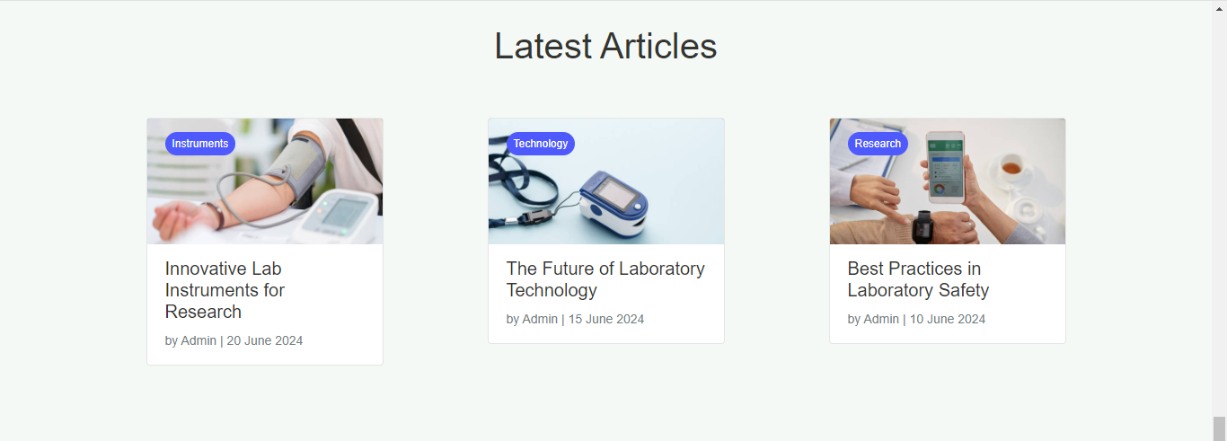

Pharmacy pages in website:

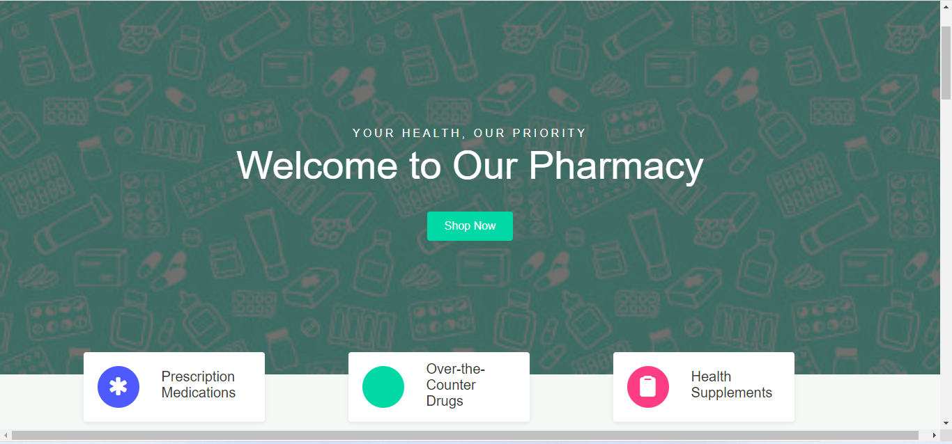

Add to cart

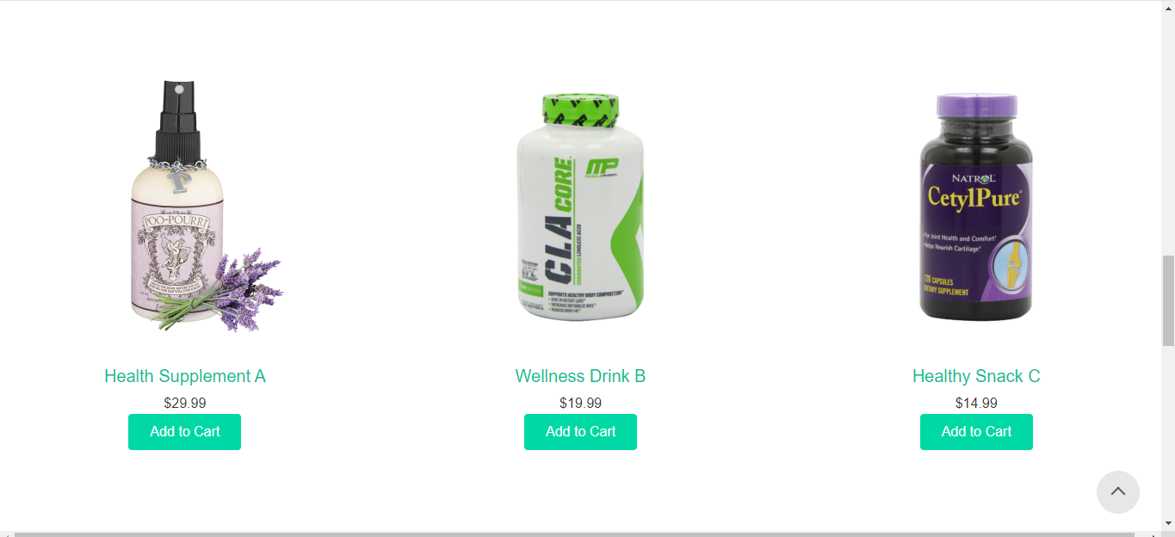

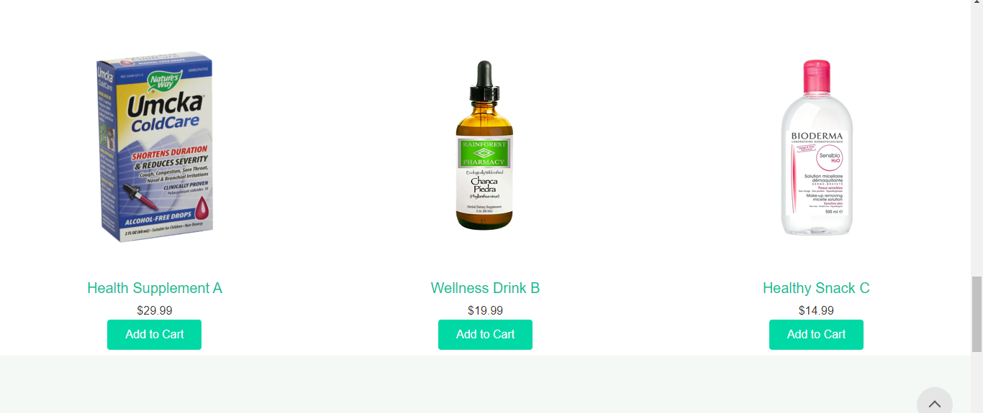

Article:

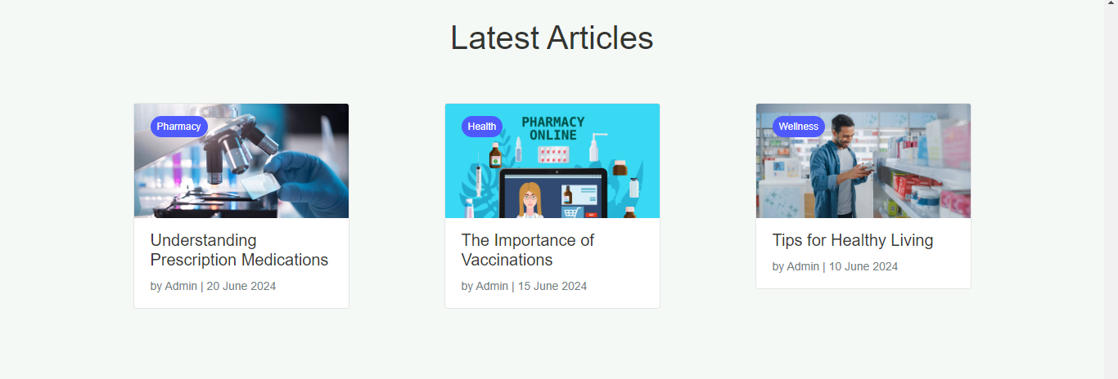

Medical Education:

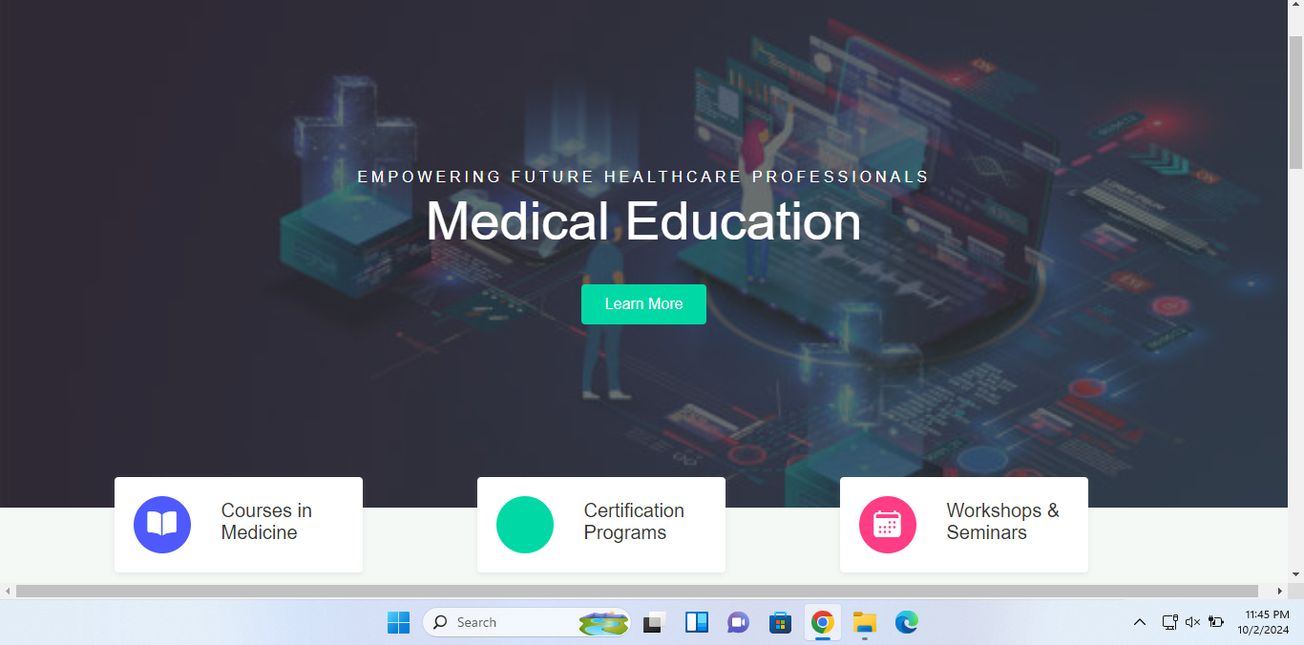

About Education :

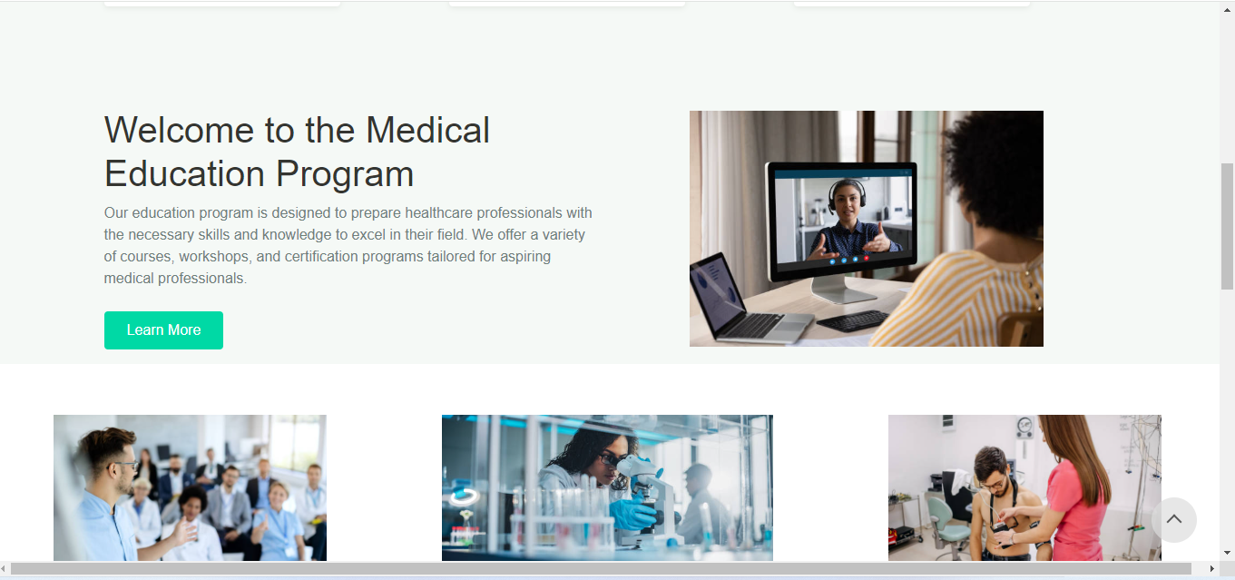

Article: Education



Goin to Ai course in Medical

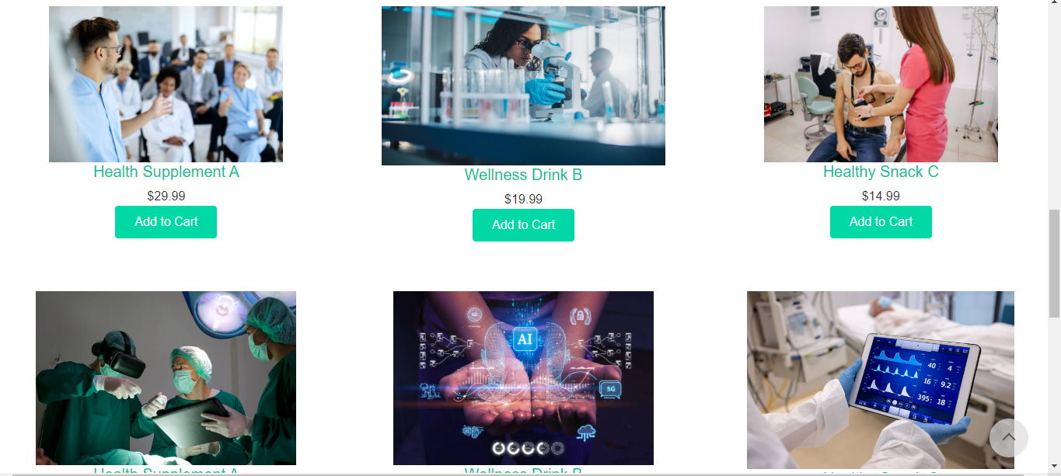

Medical Business:

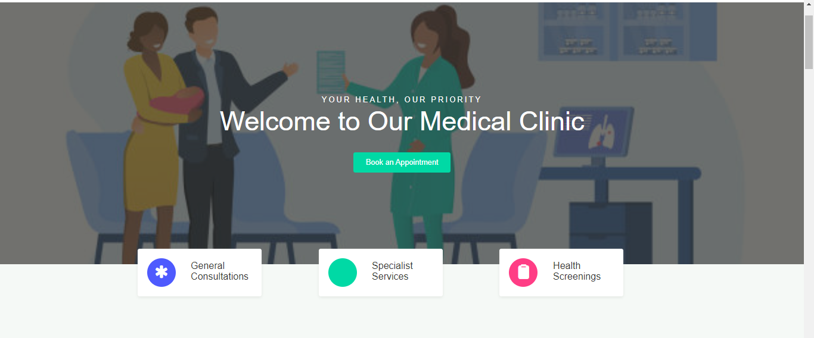

IDEA ABOUT MEDICAL BUSSINESS



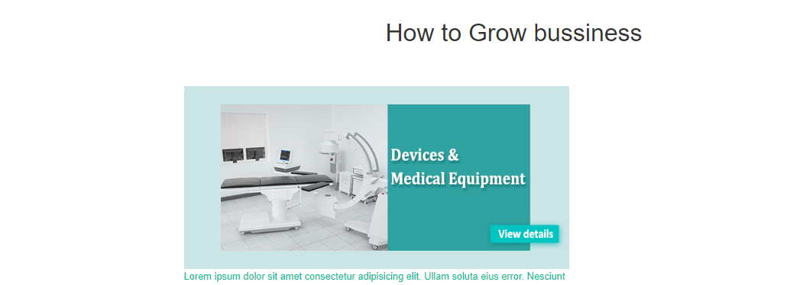

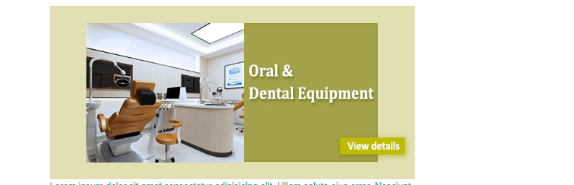

CONTACT US :

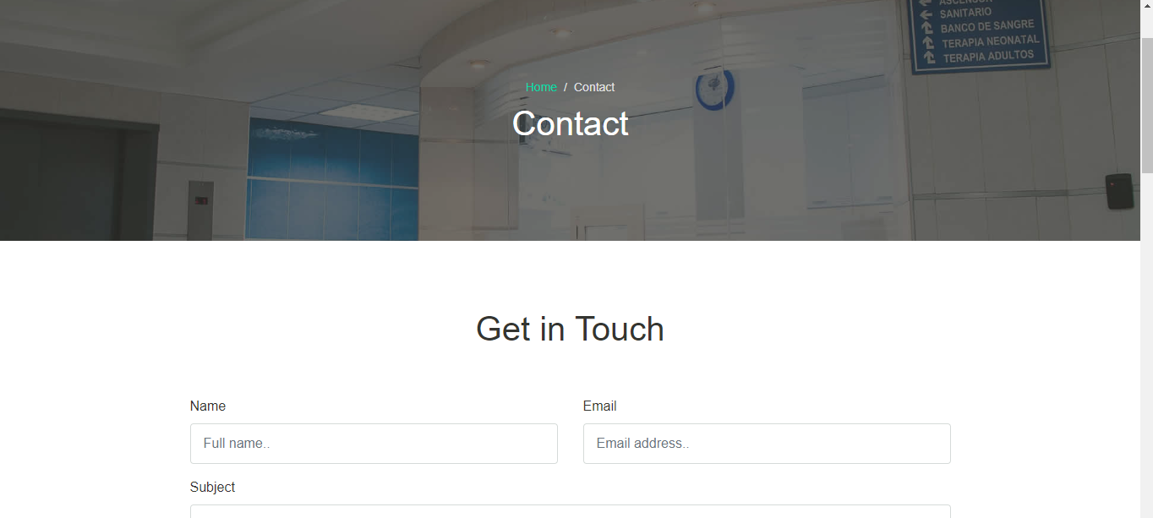

Google Map:

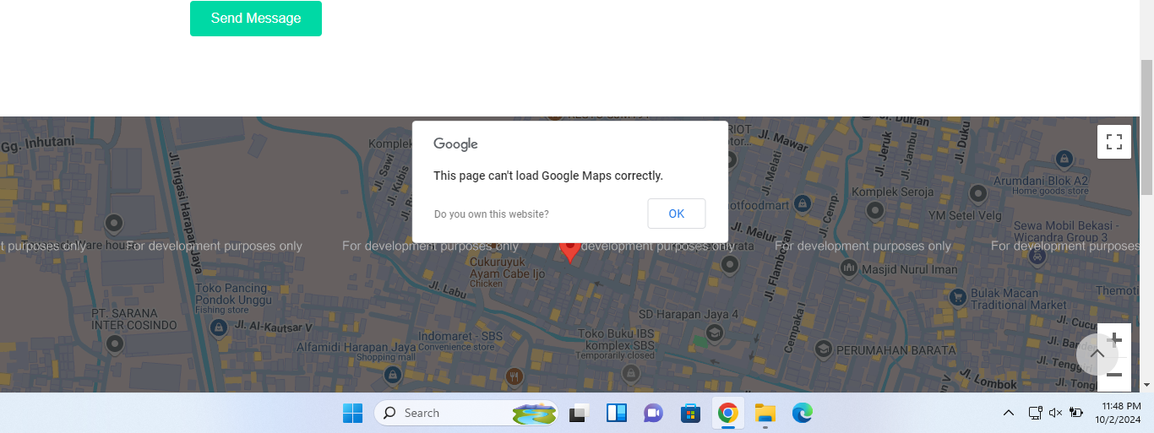

Login page:

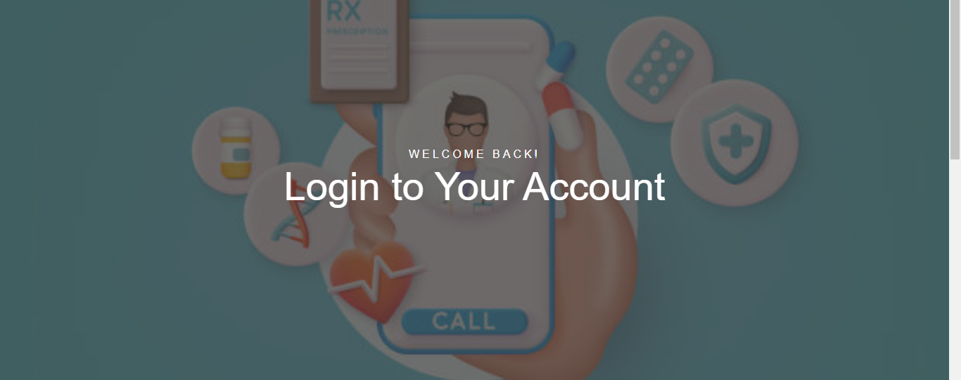

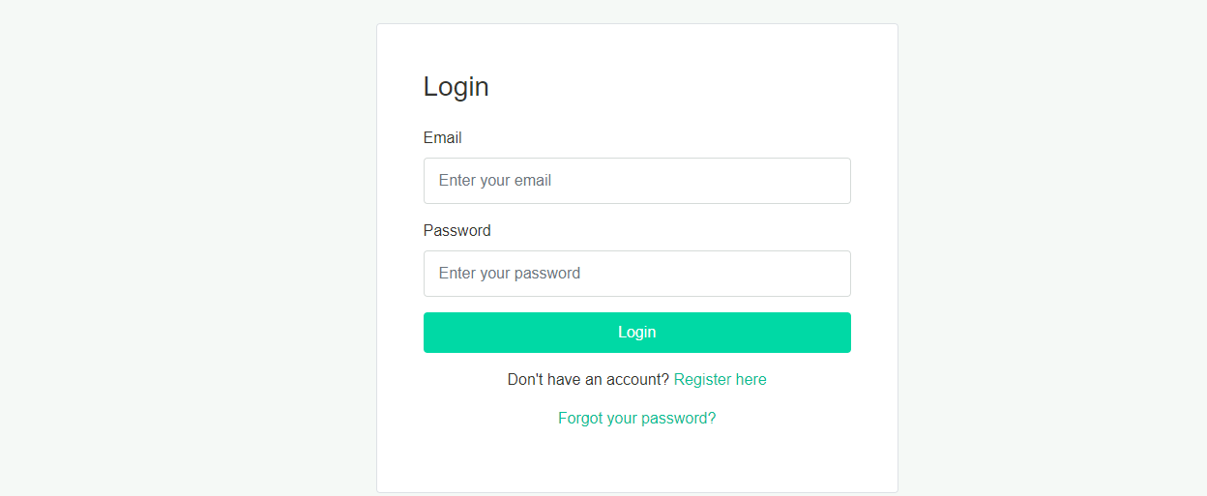

SIGNUP PAGES:



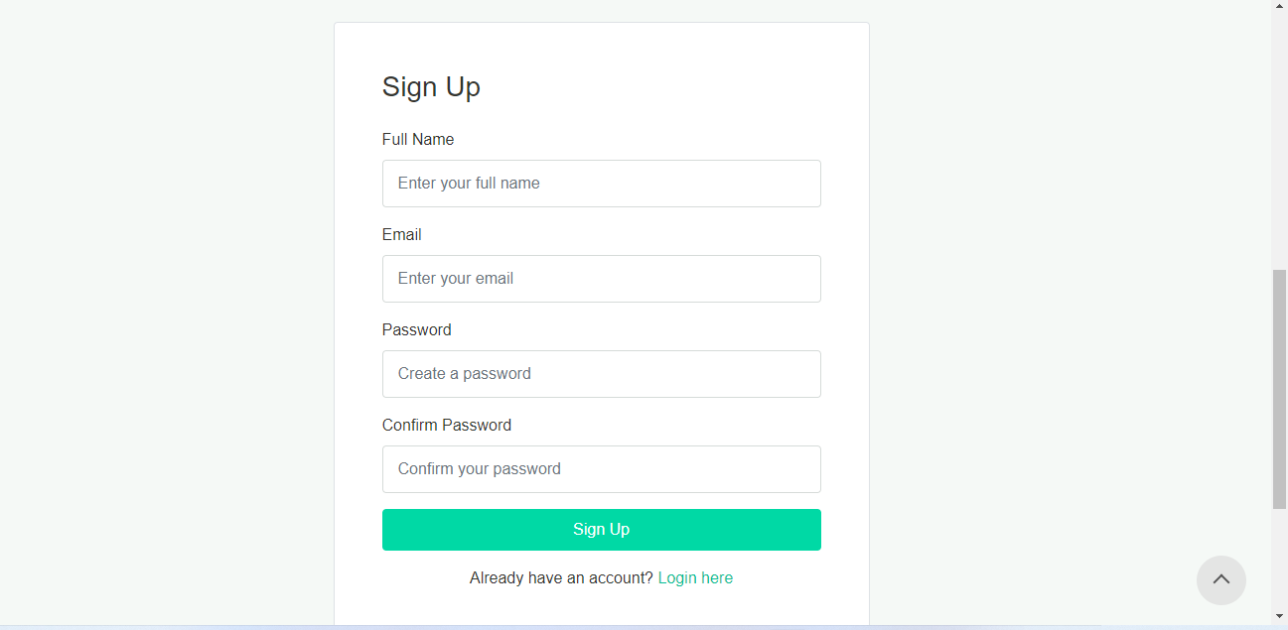

Admin Panel:

